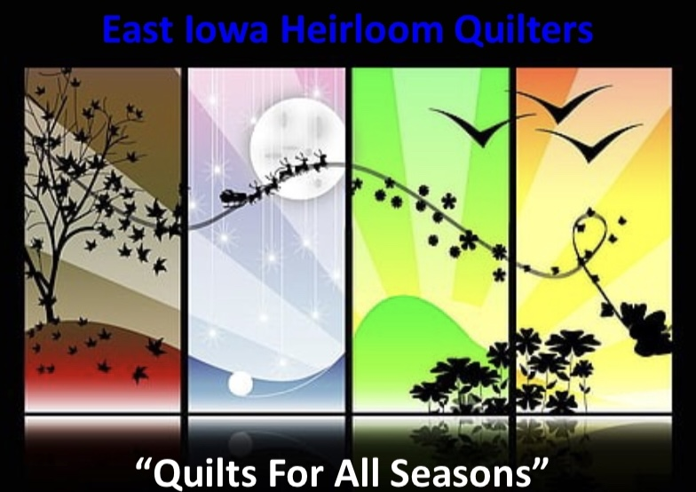

2023 EIHQ Quilt Show
Vendor Booth

The East Iowa Heirloom Quilters are planning their quilt show “Quilts for all Seasons” for July 21-22, 2023 at Prairie High School, 401 76th Avenue SW, Cedar Rapids, IA. The show hours will be from 10am to 6pm on Friday, July 21 and 9am to 5pm on Saturday, July 22, 2023. Vendors will be able to set up on Thursday from 8am to 8pm.

I am enclosing the Vendor Contract and Term of Vendor Contract. Please review them and feel free to call us if you have any questions. As shown on the contract, the deadline for returning the signed contract, payment, and your insurance certificate is March 1, 2023.

We hope you will join us for our Quilt Show. We look forward to working with you.

In addition, we are considering a vendor demo area if vendors are interested in participating in scheduled demos outside their booth. Please let us know if you are interested.

If you have any questions, please feel free to call, text or email.
Cindy Unruh Kerri Grimes
859-630-4121 714-309-8622
eihqpresident@gmail.com eihqtreasurer@gmail.com

Please send completed contracts to:
EIHQ Quilt Show 2023
Kerri Grimes
789 Bowhunter Drive
Marion, IA 52302

